RX to launch first MIPIM Middle East event in 2026
MIPIM Middle East will create a new hub for global and regional investment
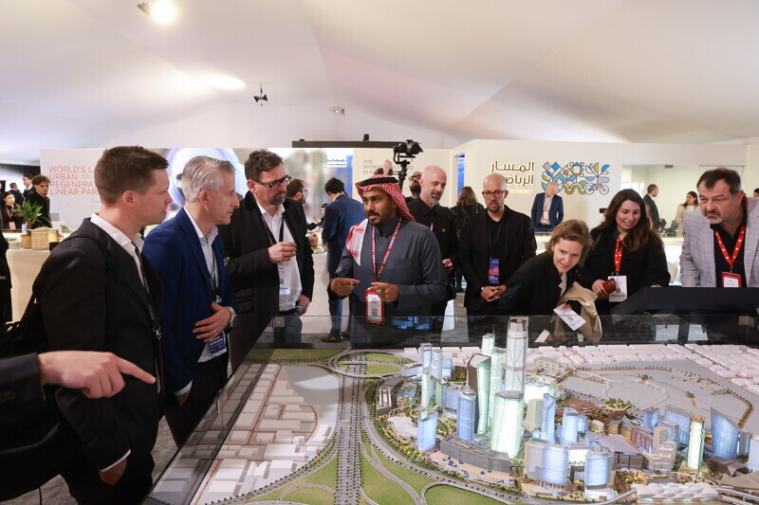
More images can be downloaded here

Riyadh, 13 November 2025. RX, a global leader in events and exhibitions and the organiser of the industry flagship MIPIM, has announced it is debuting a new show, MIPIM Middle East, on 20-21 October 2026.
To be held at the Ritz-Carlton, Riyadh, Saudi Arabia, MIPIM Middle East will bring together the international real estate and investment community with key policy makers and project owners from across the Middle East, attracting the global capital needed to realise the region’s ambitious development visions.

Known as the global urban festival, MIPIM has a long-established history as the international real estate industry’s pre-eminent trade show and conference, attracting over 20,000 delegates from around 100 countries.
Ever year its flagship event in Cannes and sister event MIPIM Asia, held in Hong Kong, connect global real estate leaders and policymakers with the largest global network of investors - representing over $4 trillion in assets looking to deploy capital – to unlock and fund major developments and city projects.
The events attract world leaders including UN Secretary Generals, Presidents, Prime Ministers and a plethora of city mayors. Notable recent delegates included mayors from London, Rome, Madrid, Athens and Copenhagen, alongside housing ministers from across the region.
In recent years, the Middle East delegation at MIPIM has grown rapidly, with countries including Saudi Arabia, Egypt, Oman, Qatar and United Arab Emirates, presenting some of the world’s most ambitious real estate and infrastructure projects to the international investment community.
MIPIM Middle East has therefore been launched to build on this momentum as the region witnesses a massive rise in development opportunities. It has chosen Riyadh due to the city’s rapidly growing prominence as a regional hub for investment, innovation and transformation in the built environment.
While the Middle East is rolling out many large-scale projects, many of them have so far been largely financed by local capital. MIPIM Middle East will provide the necessary support for these projects as the Middle East market opens to more foreign direct investment, accelerating sustainable urban development in the process.
The event will feature a curated programme designed around high-impact networking, curated content and insights, and concrete deal-making. As well as connecting policymakers and developers to investors, it will help advisors and brokers seeking to expand their presence in the region and grow their international footprint.
The programme will include keynote speeches, closed-door forums, and talks on the key issues facing real estate in the Middle East today, such as sustainable development strategies, unlocking urban investment, the role of sport and the impact of AI.
The move into one of the world’s fastest-growing real estate markets will further strengthen MIPIM’s global footprint by providing the international investment community with a second regional event outside Europe, opening doors to those looking to invest in the Middle East and North Africa region.

Vasyl Zhygalo, Managing Director, Middle East and Emerging Markets, RX said: “The launch of MIPIM Middle East in Riyadh aligns with the great potential of Saudi Arabia and the wider GCC region for real estate investment. Building on our flagship MIPIM in Cannes and MIPIM Asia in Hong Kong, MIPIM Middle East supports our ambition for the brand to become a year-round, global platform for the real estate community, international investors and political leaders to do business and drive urban transformation.”
MIPIM director Nicolas Boffi said: “By bringing MIPIM to the Middle East, we’re connecting global capital and expertise to one of the fastest growing development regions in the world. We have been incredibly impressed by the opportunities presented by our GCC partners at recent MIPIMs, including Saudi Arabia’s Vision 2030, which views real estate as a national growth engine. Our ambition is for MIPIM Middle East to be a strategic platform that will deliver lasting benefits to Saudi Arabia and the wider region by directly supporting these transformative plans.
“With the GCC poised for a property boom and an enormous investment pipeline, this is the right time to take MIPIM to the region, supporting our mission to connect public and private sector leaders to power the projects that will make the future of cities.”
ENDS
About RX
RX is a global leader in events and exhibitions, leveraging industry expertise, data, and technology to build businesses for individuals, communities, and organisations. With a presence in 25 countries across 41 industry sectors, RX hosts approximately 350 events annually. RX is committed to creating an inclusive work environment for all our people. RX empowers businesses to thrive by leveraging data-driven insights and digital solutions. RX is part of RELX, a global provider of information-based analytics and decision tools for professional and business customers. For more information, visit www.rxglobal.com.
For press – ING Media
+ 44 (0) 20 7247 8334 – mipim@ing-media.com

